Formatting a Report

Purpose of the lesson:

- To learn how to format a report
- To understand English commands

To start:

- There are four stages, each with files you need.
- Open the file for each stage (e.g. stage1.doc), complete that stage, then move onto the next stage
- Copy the text from each document into your own report (Word) document and save regularly
- Complete each stage for each part of a whole report

Instructions:

Stage 1 – Format the Introduction & Related Work Sections
Open the stage 1 word document and copy the text into your document

- Select all of the text (Crtl+A) and click on the ‘Normal’ style in ‘Styles’
- Right-click the mouse whilst over ‘Normal’ style in ‘Styles’ then select ‘Modify …’
- Check (or change to) the following values:
  - Calibri (Body) size 12 font
  - Select ‘Format’ (box in the bottom left) and Paragraph…
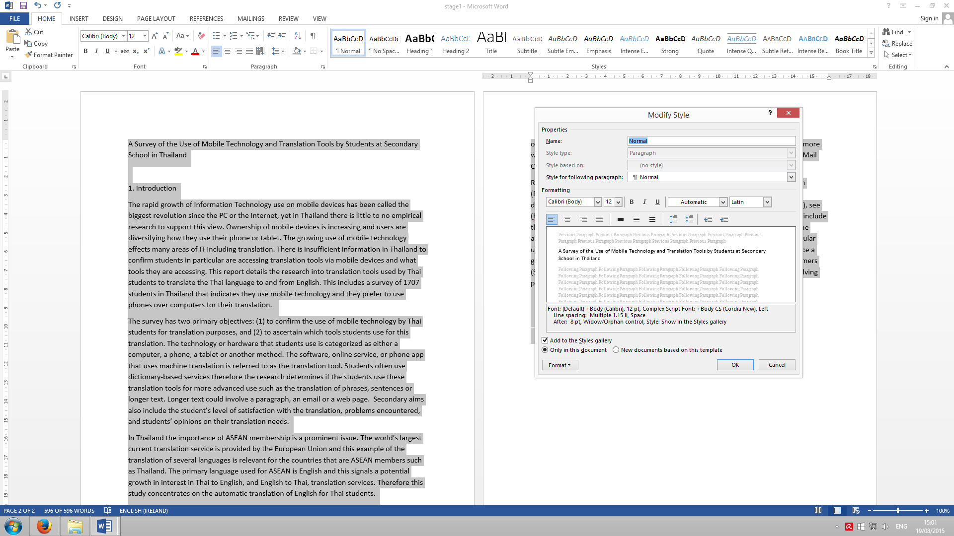
  - Multiple 1.15
  - Before 0pt
  - After 8pt
B. Select the report title ‘A Survey … School in Thailand’
- Centre and change text size to 20 ( font is Calibri(body))
C. Select the ‘1. Introduction’ heading
- Right-click the mouse whilst over ‘Heading1’ style in ‘Styles’ then select ‘Modify …’
- Check (or change to) the following values:
  - Calibri (Body) size 18 font
  - Bold and Black color
  - Select ‘Format’ (box in the bottom right) and Paragraph…
  - Multiple 1.15
  - Before 12pt
  - After 12pt
- Select Related Work heading and click on the Heading 1 style
- Save the document on the desktop with your name – use ‘Save As‘

Well Done so far!
You have completed stage 1
Remember the text and diagrams from the 4 stages make the finished report

Stage 2 – Format the Study Method Section
Open the stage 2 word document and copy the text into your document

- Select all of the text (Crtl+A) and click on the ‘Normal’ style in ‘Styles’
- Select the heading ‘study methods’ and click on the Heading1 style
- Select the ‘3.1 Research Questions’ heading and select the Heading2 style
- Right-click the mouse whilst over ‘Heading2’ style in ‘Styles’ then select ‘Modify …’
- Check (or change to) the following values
  - Bold and Black color (same Calibri (Body) size 12 font)
  - Select ‘Format’ (box in the bottom right) and Paragraph…
  - Multiple 1.15
  - Before 2pt
  - After 0pt
- Repeat for the other ‘heading2’ headings (3.2 Survey Instrument & 3.3 Sample)
- Add the stage 2 text to the end of the stage 1 text Introduction and Related Work
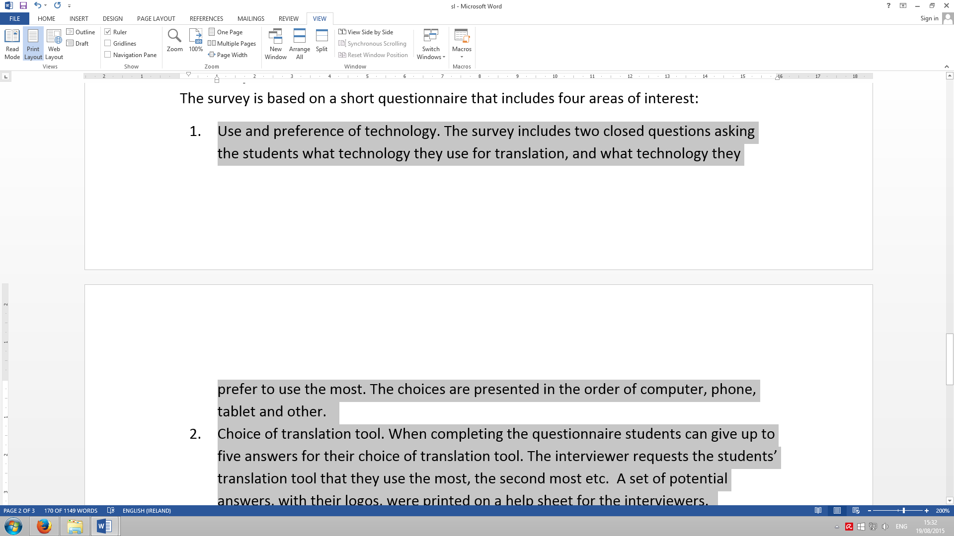
- Select the text in section 3.2 survey instrument from ‘Use and preference of technology’ to ‘Two open questions … translation needs.’
- Select the Numbering button in ‘Paragraph’ (1, 2, 3)
- With the text still highlighted change the ruler (above the document) so the top marker is set on 0.25 (¼) cm and the bottom is set on 1 cm (see figure to right).
- Save the document

Stage 3 – Insert a table & chart and complete the sections
Open the stage 3 and report table word documents and the report chart excel file from Teams

- Copy the text in stage 3 and paste it in your report
- Select all of this text (Crtl+A) and click on the ‘Normal’ style in ‘Styles’
- Select the headings and click on the Heading1 and Heading2 styles

Note: figure legends are underneath the figure, table legends are above the table.

- Copy & paste the table from the table document to your report (above 3.3. section)
- Copy & paste the chart from the chart document to your report (above figure 1)
- Make the ‘Figure 1’ legend italic
- Save your document

Note: indenting paragraphs can make your report easier to read and look better

- Indent paragraphs by selecting each paragraph in each section (not the numbered text!)
- If you prefer – keep each first paragraph in each section, without an indent.
- Using the ruler (above the document) move the top marker to 1.25 cms.
- The first paragraph in the introduction is never indented

Page Numbers

- Select the insert menu & go to the Header & Footer section
- Click Page Number, choose Bottom of Page & plain Number 2 (the second option)
- Make the ‘f’ uppercase in “in figure 1 we compare the results”, change to Figure 1

Stage 4 - Insert references (manually)
This file has the reference information, the citations in the report text and the bibliography / reference section. Copy & paste the reference text from this word document.

- Insert the reference section:
  - Go to the end of the document
  - Add a section heading called ‘References’ – style Heading 1 (don’t give it a section number)
  - Insert the references (as below)
  - Indent the references (as below)

References

Krejcie R. and Morgan D. (1970) Determining Sample Size for Research Activities, in the Educational and Psychological Measurement, issue 30, pp 607-610. [Online] Available from http://research-advisors.com/tools/SampleSize.htm [Accessed 9 Nov 2014]
Scheafler R., Mendenhall W., Ott R. and Gerow K (2012) Survey Sampling, 7th edition, International edition, Cengage Learning, Canada
Trochim W. (2006) Probability Sampling [Online] Available from: http://www.socialresearchmethods.net/kb/sampprob.php [Accessed 9 Dec 2014]

- Insert the citations in the text:
  - Go to the following sentence (in section 3.3)
Stratified random sampling involves dividing a population into homogeneous subgroups and then taking a simple random sample in each subgroup
  - Insert the following citation at the end of the sentence
(Tromchin, 2006)
  - Go to the following sentence
Stratification may produce a smaller bound of error of estimation when there are homogenous groups
  - Insert the following citation at the end of the sentence
(Schefler, Mendenhall, Ott, & Gerow, 2012)
  - Go to the following sentence
The sample from each establishment is calculated using the Krejcie and Morgan sampling method
  - Insert the following citation at the end of the sentence
(Krejcie & Morgan, 1970)

Well Done!
You have finished the report

