



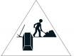
Do you ever feel like a plastic .
Drifting through the wanting to start again?
Do you ever feel, feel so thin
Like a of cards, one blow from caving in?


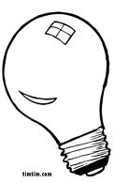
Do you ever feel already deep?
Six under screams but no one seems to hear a thing
Do you know that there’s still a chance for .
‘‘Cause there’s a spark in ?

You just gotta ignite the and let it shine
Just own the night like the .


CHORUS: ‘Cause baby, you’re a .
Come on, show ‘’em what you’re worth
Make ‘’em go, oh, oh, oh
As you shoot across the .
Baby, you’re a .
Come on, let your colors burst
Make ‘them go, oh, oh,oh You’re gonna leave ‘’em falling down



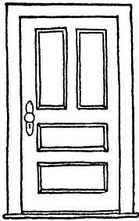
You don’’t have to feel like a waste of space
You’’re original, cannot be replaced
If you only knew what the holds .
After a hurricane comes a .
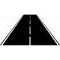

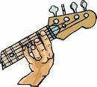
Maybe you’’re reason why all the are closed
So you could open one that leads you to the perfect .
Like a lightning bolt, your will blow
And when it’s time, you’’ll know
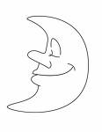
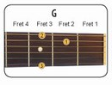
You just gotta ignite the and let it shine
Just own the night like the 4th of July
CHORUS
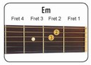
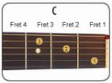
Boom, boom, boom
Even brighter than the .
It’’s always been inside of you, you, you
And now it’’s time to let it through

